Final Paper
Topic: Advanced Distributed Systems

Thesis Title
Design and Performance Analysis of a
Hierarchical Blockchain Architecture for High-Frequency Micropayment Systems
Student: Cui Yang
Student ID: 50260230
Advisor: Baek KeonHyo
June 2026
Graduate School of Youngsan University
Major in Computer Engineering

CONTENTS
LIST OF TABLES iii
LIST OF FIGURES iv
I. Introduction 1
1. Research Background 1
2. Research Significance and Objectives 2
2.1 Research Significance 2
2.2 Research Objectives 3
3. Research Method and Main Contributions 3
3.1 Research Method 3
3.2 Main Contributions 4
4. Structure of the Thesis 4
II. Related Work 6
1. Blockchain Scalability Research 6
2. Off-chain and Layer 2 Solutions 7
3. Rollup-based Scaling Methods 7
4. Architectures Dedicated to Micropayments 8
5. Limitations of Existing Studies and Differentiation of This Study 9
III. Research Method and System Design 11
1. Research Type and Research Target 11
2. Comparative Systems 11
3. System Components 12
4. Design Principles of the Hierarchical Architecture 13
5. Data Flow and Ethical Considerations 14
IV. Experimental Design and Evaluation Method 16
1. Experimental Objective 16
2. Experimental Environment 16
3. Load Conditions and Comparison Groups 18
4. Evaluation Metrics 18
5. Experimental Procedure 19
V. Results and Analysis 21
1. Throughput and Scalability Results 21
2. Latency and Resource Utilization Results 23
3. Cost Efficiency Results 24
4. Security Integrity Verification Results 25
5. Interpretation by Research Question 27
VI. Conclusion and Future Work 29
1. Summary of Findings 29
2. Academic Implications 29
3. Practical and Technical Implications 30
4. Limitations of the Study 31
5. Future Research Directions 31
REFERENCES 33
KOREAN ABSTRACT 35
ABSTRACT 37
APPENDIX 39

LIST OF TABLES
Table III-1. Components and Roles of the Proposed System 12
Table IV-1. Hardware and Software Environment of the Experimental System 16
Table IV-2. System Characteristics and Comparison Points by Comparison Group 18
Table V-1. Throughput (TPS) by Comparison Group under Changing Input Loads 21
Table V-2. Average Latency and CPU Utilization under Increasing Input Loads 23
Table V-3. Transaction Gas Consumption and Cost Efficiency 24
Table V-4. Tampered Transaction Detection Rate and Integrity Verification Results 26
Appendix Table D-1. Summary of Python Code Execution Results 40
Appendix Table E-1. Correspondence between Output Files and Thesis Tables 41
Appendix Table F-1. Summary of Key Experimental Values 44

LIST OF FIGURES
Figure II-1. Classification of Blockchain Scalability Approaches 9
Figure III-1. Structural Comparison of Vanilla, Off-chain, and Proposed Architectures 13
Figure III-2. Overall Data Flow of the Proposed Hierarchical Blockchain Architecture 15
Figure IV-1. Relationship between Experimental Environment and Technology Stack 17
Figure V-1. TPS Scalability Comparison under Increasing Input Loads 22
Figure V-2. Average Latency Comparison under Increasing Input Loads 24
Figure V-3. Average Transaction Fee Comparison by Architecture 25
Figure V-4. Attack Attempts, Successful Detections, and Detection Rate by Scenario 27

I. Introduction

1. Research Background
Blockchain technology was initially proposed as a distributed ledger for peer-to-peer electronic cash transactions. Since then, it has evolved into a general-purpose distributed system infrastructure that supports tamper-resistant data management, transaction history tracking, and smart-contract-based automated execution. From the perspective of payment systems, the core advantage of blockchain lies in its ability to verify the integrity of transaction records without relying on a central authority. This characteristic is particularly important in micropayment environments where many small-value transactions repeatedly occur, such as digital content billing, Internet of Things data trading, API usage settlement, and machine-to-machine automatic payment. However, in a single-layer structure where all transactions must be executed and agreed upon directly on the base chain, throughput limitations, finality delay, and high fees can occur simultaneously [1], [2].
High-frequency micropayments have requirements that differ from those of ordinary payment services. First, because the value of each transaction is small, transaction fees must not exceed the payment amount. Second, transaction requests may occur in large volumes within a short time through user clicks, content consumption, sensor data transmission, API calls, or machine-to-machine service usage. Third, service quality is highly sensitive to latency. If a transaction is delayed for more than several seconds, user experience and operational stability can deteriorate in services that require real-time charging or immediate settlement. Therefore, high-frequency micropayment systems must simultaneously satisfy high throughput, low latency, low transaction cost, and verifiable security [4].
Single-layer blockchains have advantages in terms of security and verifiability. Nevertheless, they are likely to encounter bottlenecks in high-frequency transaction environments because all transaction execution and verification are handled within the same layer. Even when input load increases, block generation intervals, block size, network propagation delay, consensus cost, and state storage burden jointly prevent actual throughput from increasing beyond a certain level. In micropayments, transaction fees are a key determinant of economic feasibility; therefore, simply recording every transaction on a secure chain restricts practical applicability [2], [3].
To mitigate these limitations, recent research on blockchain scalability has focused more on reallocating roles between execution and verification layers than on simply improving the performance of a single chain. Layer 2 handles frequent transaction execution and state transitions, while Layer 1 records state roots, provides security anchoring, and supports dispute verification. Rollup-based structures reduce the cost per transaction and reduce the burden on the base chain by compressing many off-chain execution results into one batch and submitting it to Layer 1. Based on this perspective, this study designs a hierarchical blockchain architecture for high-frequency micropayment systems and comprehensively analyzes performance, cost, and security integrity by comparing it with conventional single-layer and simple off-chain approaches [5], [6], [9].

2. Research Significance and Objectives

2.1 Research Significance
The first significance of this study is that it connects the discussion of blockchain scalability with the concrete application requirements of high-frequency micropayments. A micropayment system is not sufficient merely because it is decentralized. Low latency, stable availability, transaction fees that do not exceed the payment amount, and transaction records that can be verified after the fact are also required. Accordingly, this study treats not only TPS but also cost efficiency and security integrity as equally important evaluation criteria.
The second significance is that the study supplements the limitations of simple off-chain approaches by incorporating Layer 1 security anchoring and Fraud Proof-based verification. Although off-chain systems can provide fast processing and low cost, users may find it difficult to verify the correctness of transaction states when state data is unavailable or dispute evidence is insufficient. This study seeks a balance between performance and verifiability by linking Layer 2 execution results to Layer 1.
The third significance is that the study presents a design direction that places execution, batching, verification, and final security functions in different layers from the perspective of modular blockchain architecture. This expands the view of blockchain from a single ledger into a distributed system design problem in which functions are hierarchically arranged according to service requirements.

2.2 Research Objectives
The first objective of this study is to design a hierarchical blockchain architecture for high-frequency micropayment systems. The proposed architecture separates Layer 2 execution from Layer 1 verification and aims to reduce base-chain submission frequency and cost per transaction through Rollup-based batch processing.
The second objective is to compare the proposed architecture with a Vanilla single-layer blockchain and a simple Off-chain method and analyze the performance differences. This comparison clarifies the limitations of direct on-chain processing and simple off-chain processing and evaluates the conditions under which the proposed architecture is advantageous.
The third objective is to evaluate throughput, latency, CPU utilization, transaction cost, system availability, and security integrity together. This multidimensional evaluation provides a more realistic judgment of the practical applicability of micropayment systems.

3. Research Method and Main Contributions

3.1 Research Method
This study is an engineering performance evaluation study. It does not merely present a conceptual design; rather, it defines comparison groups, input loads, evaluation metrics, and security integrity scenarios, and then analyzes experimental results. The purpose is to verify whether the proposed hierarchical blockchain structure has practical applicability in high-frequency micropayment systems.
The comparison structure consists of three systems. Vanilla is the baseline model in which all transactions are processed directly on a single-layer blockchain. Off-chain is a simple off-chain model that moves transaction execution outside the chain to reduce cost and latency. Proposed is the proposed model that combines Layer 2 execution, Rollup batch processing, Layer 1 security anchoring, and Fraud Proof verification.
This comparison-group design is intended to reveal the advantages and limitations of each method. Vanilla has strong verifiability but is likely to saturate early under high load. Off-chain provides low cost and fast response but has limitations in data availability and verifiability. The Proposed Rollup aims to provide a balanced structure by combining Layer 2 performance with the security anchor of Layer 1.

3.2 Main Contributions
First, this study proposes an execution-verification-separated hierarchical architecture for high-frequency micropayments. This structure places frequent transaction execution in Layer 2 while maintaining the final security anchor in Layer 1, thereby reducing the burden on the base chain.
Second, the study analyzes performance changes under increasing load using three comparison groups: Vanilla, Off-chain, and Proposed. By observing changes at each load level rather than relying on a single value, the study identifies early saturation, high-load latency increase, and differences in Rollup-based scalability.
Third, the study integrates cost and security verification into performance analysis. The Proposed method is evaluated not only by TPS but also by transaction-fee reduction, system availability, and Fraud Proof detection rate. This is because both economic feasibility and reliability are important in micropayment services.

4. Structure of the Thesis
This thesis consists of six chapters. Chapter I explains the research background, significance and objectives, research method, and main contributions. It also presents why high-frequency micropayments are difficult for single-layer blockchains and why a hierarchical structure is necessary.
Chapter II reviews prior studies on blockchain scalability, off-chain and Layer 2 solutions, Rollup-based scaling methods, and architectures dedicated to micropayments. Through this review, the limitations of existing studies and the differentiation of this study are clarified.
Chapter III describes the research method and system design, including comparative systems, system components, design principles of the hierarchical architecture, data flow, and ethical considerations. Chapter IV explains the experimental environment, load conditions, comparison groups, evaluation metrics, and experimental procedure. Chapter V analyzes the experimental results in terms of throughput, latency, cost efficiency, and security integrity, while Chapter VI presents conclusions and future research directions.

II. Related Work

1. Blockchain Scalability Research
The blockchain scalability problem originates from the structural cost of distributed consensus. In a general blockchain, every validating node must verify transactions and maintain the same ledger state. This method provides tamper resistance and auditability, but it limits transaction finality speed and throughput. Consensus algorithms, block intervals, block size, network propagation delay, and state storage cost all affect actual throughput. Therefore, scalability should be understood not as a single metric but as a multidimensional problem that combines computational, communication, storage, and verification burdens [2], [3].
Consensus-algorithm-based approaches aim to improve performance by improving the way transaction order is agreed upon. Byzantine Fault Tolerance protocols, proof-of-stake mechanisms, and permissioned blockchain consensus structures can provide high throughput in specific environments. However, in high-frequency micropayments, consensus speed alone is insufficient. If every small-value transaction is recorded individually on the base chain, fee burdens remain large, and sudden load increases can lead to queue accumulation and finality delay [7], [8].
Sharding and state partitioning are scaling methods that divide a network into multiple areas and perform parallel processing. Although this approach is meaningful from a scale-out processing perspective, it creates additional issues such as cross-shard transactions, state synchronization, shard security, and cross-shard message processing. In environments such as high-frequency micropayments where many small state changes occur continuously, these coordination costs can become new bottlenecks. Thus, sharding is an important axis of scalability discussions but has limitations as a standalone solution for micropayment cost and latency problems [8], [11].

2. Off-chain and Layer 2 Solutions
Off-chain solutions reduce the burden on the base chain by processing frequent interactions outside the base chain. In a state-channel method, participants exchange signed state updates off-chain and submit only the final state or dispute evidence to the blockchain. When participants are fixed and transactions occur repeatedly, state channels can provide low latency and low fees. However, channel opening and closing costs, liquidity lock-up, online monitoring, and dispute-response requirements exist, so applicability may be limited for services with many dynamic participants [4].
Layer 2 solutions go beyond simple off-chain execution and construct an execution environment logically connected to Layer 1. Layer 2 handles transaction execution but maintains verifiability by linking state roots, proof information, and dispute data to Layer 1. This distinguishes Layer 2 from an ordinary external database. External databases may be fast, but data availability and integrity verification can be weak. Layer 2, by contrast, seeks to combine the efficiency of off-chain execution with Layer 1 security assumptions [5], [6].
In micropayment environments, Layer 2 is suitable because it can process many small-value transactions quickly and submit summarized results to Layer 1. However, Layer 2 design must balance real-time responsiveness, cost reduction, and verifiability. If batches are submitted too frequently, cost savings decline; if they are submitted too late, finality delay and dispute-processing issues may arise. Therefore, batch size, submission interval, Fraud Proof strategy, and data availability policy are key control variables in hierarchical payment systems.

3. Rollup-based Scaling Methods
Rollup is a representative Layer 2 scaling method that executes transactions outside the base chain and submits the results to Layer 1 in compressed batches. Optimistic Rollup assumes submitted states are valid, but if a Fraud Proof is submitted within a defined period, the invalid state is reverted. ZK-Rollup submits a cryptographic proof that the state transition is correct. Although the verification principles differ, both methods reduce the data and computation that the base chain must process directly [9], [10].
The Rollup structure is especially important for high-frequency micropayments. When many small-value transactions are bundled into one batch, Layer 1 submission costs can be distributed across many transactions. This structure mitigates the fee inversion problem in which transaction fees exceed the transaction amount. In addition, Layer 2 can respond quickly to user requests, while Layer 1 periodically records compressed state information, separating the roles of performance and security [9], [11].
However, Rollup design is not merely a performance optimization problem but also a security and operational problem. Users must be able to reconstruct or verify Layer 2 states, so data availability must be ensured. Fraud Proofs must clearly define which state transitions are invalid, and dispute periods and finality policies are also required. Thus, Rollup-based micropayment systems must design throughput, cost, data availability, and verification procedures together.

4. Architectures Dedicated to Micropayments
Micropayment systems have characteristics different from conventional retail payment networks. An individual transaction may represent a small event such as viewing a piece of content, watching a short video segment, calling an API once, uploading sensor data, or using a machine-to-machine service. Since transaction amounts are very small, the payment system must minimize transaction fees while maintaining high request-processing capacity and low latency. At the same time, transaction histories must be verifiable after the fact, and operators must not be able to arbitrarily manipulate states.
A hierarchical structure is suitable for these requirements. A local execution layer processes frequent state changes and balance updates quickly, while a global security layer stores compressed evidence of execution results. This resembles a local-global settlement structure. The local layer handles immediacy and throughput, while the global layer handles final settlement and dispute resolution. Such division of labor supports high-frequency activity while preserving blockchain verifiability [4], [5].
The proposed architecture in this study follows this principle. Layer 2 handles transaction simulation, signature verification, state transition, batch generation, and Rollup preparation. Layer 1 receives state roots and verification information and functions as a security anchor. The Fraud Proof module detects balance-state tampering, double-spending signature injection, and invalid batch commits. This study sets Vanilla single-layer blockchain and simple Off-chain methods as comparison groups to analyze whether the proposed structure improves not only throughput but also cost and integrity.
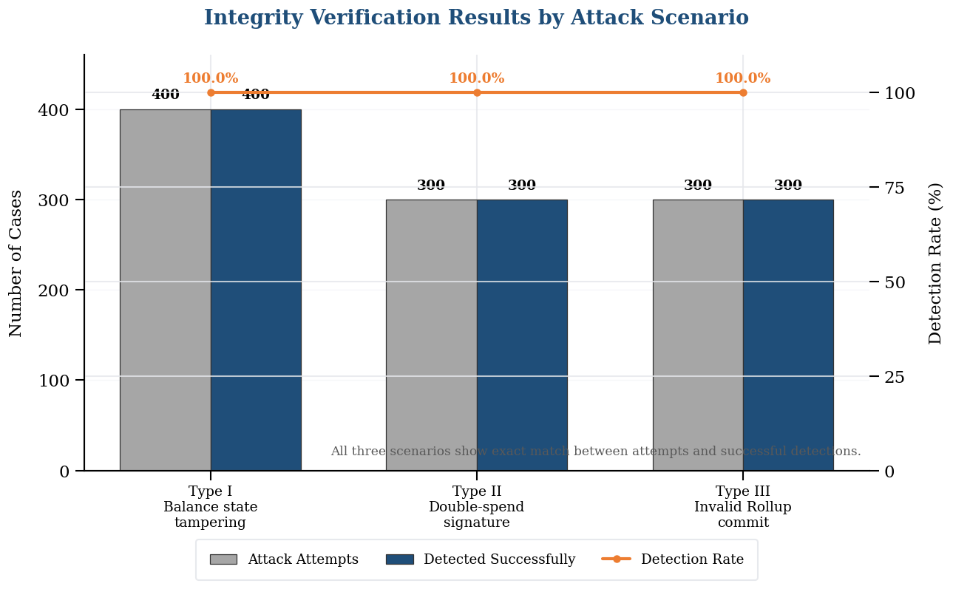
Figure II-1. Classification of Blockchain Scalability Approaches

5. Limitations of Existing Studies and Differentiation of This Study
Although existing scalability studies have presented various methods to alleviate blockchain throughput problems, several gaps remain in high-frequency micropayment environments. First, many studies focus on TPS-centered performance metrics and do not evaluate transaction cost, average latency, system availability, and security integrity together. Second, simple off-chain methods can reduce cost but may be weak in data availability and dispute verification. Third, some Layer 2 studies explain general mechanisms, but integrated performance analysis under stepwise increasing input loads remains limited.
To address these gaps, this study designs a hierarchical blockchain architecture and performs multidimensional evaluation. The evaluation includes average latency, CPU utilization, transaction fee, availability, and Fraud Proof detection rate in addition to TPS. The study also interprets results according to RQ1–RQ3, strengthening the connection between system design, experimental procedure, result analysis, and conclusion. In this respect, this study examines the practical applicability of micropayment systems more concretely.

III. Research Method and System Design

1. Research Type and Research Target
This study is an engineering performance evaluation study. It defines comparison groups, input loads, evaluation metrics, and security integrity scenarios, and analyzes experimental results rather than presenting only a conceptual design. The purpose is to determine whether the proposed hierarchical blockchain structure has practical applicability in high-frequency micropayment systems.
The comparison structure consists of three systems. Vanilla is a baseline model in which all transactions are processed directly on a single-layer blockchain. Off-chain is a simple off-chain model that moves transaction execution outside the chain to reduce cost and latency. Proposed combines Layer 2 execution, Rollup batch processing, Layer 1 security anchoring, and Fraud Proof verification.
This setup reveals both the advantages and limitations of each approach. Vanilla is strongly verifiable but likely to saturate early under high load. Off-chain provides low cost and fast response but has limitations in data availability and verifiability. Proposed Rollup aims to provide a balanced structure by combining Layer 2 performance with the Layer 1 security anchor.

2. Comparative Systems
The Vanilla system is the first comparison group and represents a model in which all micropayment transactions are processed directly on a single-layer public blockchain. This method reflects the traditional blockchain processing method and is meaningful as a baseline. However, as input load increases, limitations in base-chain throughput and finality speed are expected to become evident.
The Off-chain system is the second comparison group and refers to a simple state-channel or external-execution model in which transaction execution is processed outside the chain. This method can provide fast response and low cost at low load. However, it may have limitations in data availability, state synchronization, and dispute verification, and latency may increase under high load.
The Proposed system is the hierarchical Rollup architecture designed in this study. In this structure, Layer 2 executes frequent transactions, the Rollup module compresses transactions into batches, the Fraud Proof module verifies invalid states, and Layer 1 records state roots and verification information. The Proposed system aims to achieve a balance between performance and verifiability.

3. System Components
Table III-1. Components and Roles of the Proposed System
Component | Role
Node.js Transaction Simulator | Generates high-frequency micropayment requests in the range of 100–5,000 RPS
Layer 2 Service Chain | Executes high-frequency transactions and temporarily updates states
Data Rollup Module | Compresses executed transactions and packages them into batches
Fraud Proof Module | Detects state tampering, double-spending signatures, and invalid Rollup commits
Layer 1 Network | Records state roots, provides security anchoring, and supports dispute verification

The Node.js transaction simulator acts as the load generator in the experimental architecture. It generates high-frequency payment requests according to input loads ranging from 100 RPS to 5,000 RPS. The submitted Python code reproduces and visualizes these experimental results, while the conceptual system design in the thesis assumes a Private Ethereum, Solidity, Node.js, and Web3.js-based environment.
The Layer 2 service chain is the execution layer. It handles transaction signature verification, balance-state updates, and preparation of execution results for Rollup batch generation. Since micropayment transactions are frequent and small in value, placing execution in Layer 2 can reduce direct processing burden on Layer 1. Layer 2 is not an independent database; rather, it is connected to Layer 1 through state roots and Fraud Proofs.
The Rollup module bundles multiple Layer 2 transactions into one batch and creates compressed state commitments. The Fraud Proof module provides a procedure for verifying incorrect submissions. If an operator arbitrarily modifies balances, injects double-spending signatures, or attempts to commit an invalid batch to Layer 1, the verification process detects inconsistency between the expected state and the submitted state.
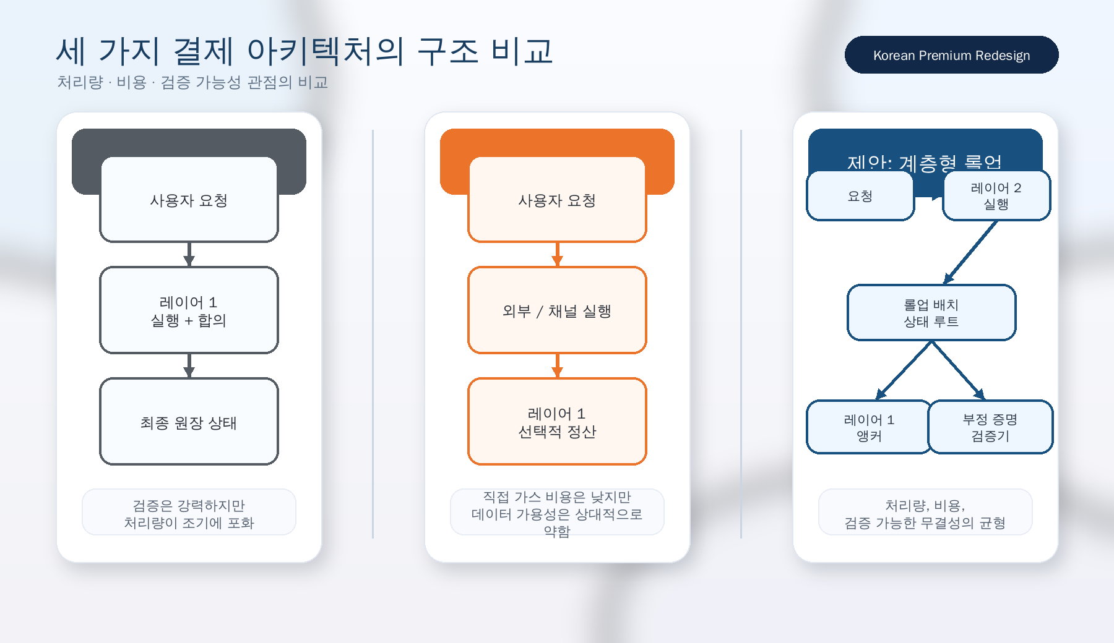
Figure III-1. Structural Comparison of Vanilla, Off-chain, and Proposed Architectures

4. Design Principles of the Hierarchical Architecture
The first design principle of the proposed architecture is role separation. Layer 2 optimizes execution and responsiveness, while Layer 1 handles final security and verification. If one chain performs all functions simultaneously, bottlenecks are likely under high load. By separating functions hierarchically, transaction throughput can be improved while maintaining the security anchor of the base chain.
The second principle is batch-based cost distribution. Instead of paying a Layer 1 fee for every individual micropayment, many transactions are summarized into one batch and submitted. As a result, Layer 1 submission cost is distributed across many transactions, reducing the average cost per transaction. This is the key reason the Proposed system records lower transaction fees than the Vanilla method.
The third principle is verifiable integrity. Performance improvement alone cannot make off-chain states trustworthy. Therefore, the proposed architecture includes Fraud Proof verification and Layer 1 anchoring. This mechanism detects invalid state changes within the defined threat model and enables users to trust Layer 2 execution results in a verifiable way.

5. Data Flow and Ethical Considerations
The data flow begins when the transaction simulator generates micropayment requests. Generated requests are delivered to Layer 2, where transaction validity verification and state transitions are performed. Executed transactions are collected by the Rollup module and transformed into compressed batch commitments, which are submitted to Layer 1. If an invalid batch or tampered state is found, the Fraud Proof module performs verification and detects the inconsistency.
This study uses simulated transaction data generated in an experimental environment rather than actual user payment records. It does not collect real personal information, sensitive financial information, or actual mainnet cryptocurrency transaction data. This is important from a research ethics perspective because the purpose of the study is not user behavior analysis but architecture-level performance and integrity evaluation.
Accordingly, the system design satisfies both technical and ethical requirements. Technically, it provides a structured processing path from high-frequency request generation to Layer 1 verification. Ethically, it excludes sensitive information collection and performs experiments within the scope of controlled simulation and performance analysis.
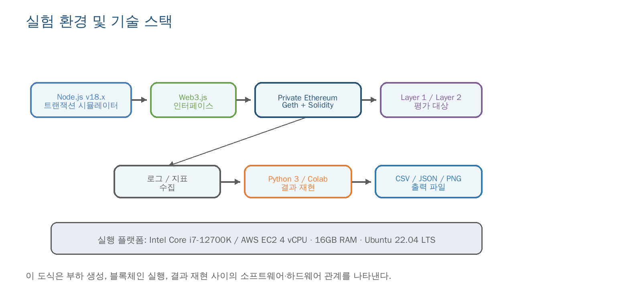
Figure III-2. Overall Data Flow of the Proposed Hierarchical Blockchain Architecture

IV. Experimental Design and Evaluation Method

1. Experimental Objective
The experiment was designed to increase input load step by step from 100 RPS to 5,000 RPS. This stepwise load design is useful not only for measuring the maximum processing performance of each system but also for observing performance changes as load increases. Even if a system is stable at low load, performance can deteriorate sharply in high-traffic environments due to queue accumulation, synchronization delay, and consensus bottlenecks.
The evaluation metrics reflect the requirements of micropayment systems. TPS indicates the number of transactions processed per second, and average latency is a criterion for determining whether a service can provide real-time responsiveness. Transaction cost is a key metric for evaluating the economic feasibility of small payments, while availability indicates whether the system can remain operational under high load. Security integrity evaluates whether Layer 2 state tampering or invalid batches can be detected.

2. Experimental Environment
Table IV-1. Hardware and Software Environment of the Experimental System
Item | Description
CPU | Intel Core i7-12700K / AWS EC2 4 vCPU
RAM | 16GB
OS | Ubuntu 22.04 LTS
Blockchain Framework | Private Ethereum (Geth), Solidity
Load Generation and Integration | Node.js v18.x, Web3.js
Python Reproduction Environment | Python 3 / Google Colab-based result reproduction and visualization

The experimental environment was configured to represent a controlled blockchain performance evaluation environment. From the blockchain perspective, the environment assumes Private Ethereum, Solidity smart contracts, and integration with Node.js and Web3.js. The submitted Python code reproduces the experimental results in Chapter V, generates tables and figures, and enables result verification in Google Colab.
A controlled environment was used because public blockchain networks are affected by dynamic gas prices, unpredictable network congestion, and the behavior of external validators. A private environment makes it possible to focus on relative performance differences among comparison groups. However, such a controlled environment also limits the generalization of numerical results to real commercial networks.
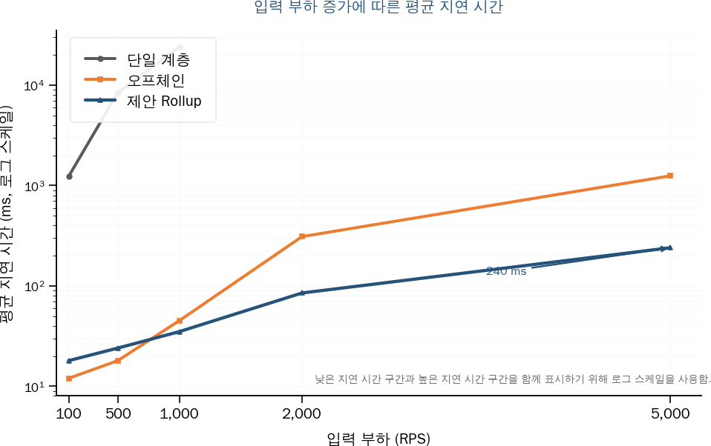
Figure IV-1. Relationship between Experimental Environment and Technology Stack

3. Load Conditions and Comparison Groups
Table IV-2. System Characteristics and Comparison Points by Comparison Group
Comparison Group | System Characteristics | Comparison Point
Comparison Group A (Vanilla) | Single-layer public blockchain | Scalability limitation and transaction cost
Comparison Group B (Off-chain) | Simple state channel or off-chain method | Data availability and synchronization delay
Proposed Method (Proposed) | Hierarchical architecture + Rollup | Throughput, cost, and security integrity

The input loads were set to five levels: 100, 500, 1,000, 2,000, and 5,000 RPS. These values were selected to observe system behavior from low load to high load. In high-frequency micropayment systems, maintaining stable throughput and latency under increasing load is more important than performance at low load alone.
The comparison groups were designed to reveal different architectural trade-offs. Vanilla provides strong verifiability through direct base-chain processing but has limited scalability. Off-chain prioritizes speed and cost reduction but may have relatively weak verifiability. Proposed Rollup attempts to combine the advantages of both methods by integrating Layer 2 execution with a Layer 1 verification anchor.

4. Evaluation Metrics
Throughput is measured as transactions per second (TPS). TPS indicates the number of transactions the system can actually process under a specific input load. A scalable system should increase throughput as input load increases until it reaches its design limit.
Latency is measured as the average transaction processing delay in milliseconds. Low latency is essential for real-time micropayment services. CPU utilization is used as an additional resource usage metric because CPU saturation can cause queue growth and system instability.
Transaction cost is evaluated by gas consumption and average fee per transaction. Since micropayments involve small amounts, they cannot tolerate high transaction fees. Therefore, cost per transaction is as important as throughput as a practical metric.
Security integrity is evaluated by the detection rate of tampered or invalid transactions. The experiment uses three attack scenarios: arbitrary tampering of Layer 2 balance states, double-spending signature injection in a state channel, and forced Layer 1 commitment of an invalid Rollup batch.

5. Experimental Procedure
The experiment was conducted step by step to compare the performance and security integrity of the proposed hierarchical blockchain architecture under the same conditions. First, an experimental environment including Private Ethereum, a Layer 2 service chain, a Rollup module, a Fraud Proof module, and a Node.js-based transaction simulator was configured. Then, the three comparison groups—Vanilla, Off-chain, and Proposed—were executed under the same hardware and software conditions.
Next, micropayment requests were generated while the input load was increased step by step to 100, 500, 1,000, 2,000, and 5,000 RPS. At each load level, TPS, average latency, CPU utilization, transaction cost, and system availability were collected. This made it possible to compare not only low-load behavior but also throughput changes, latency growth, and resource usage patterns under high-load conditions.
Finally, three attack scenarios were injected to verify security integrity: Layer 2 balance-state tampering, double-spending signature injection, and invalid Rollup batch commitment. After recording whether the Fraud Proof module successfully detected each case, the collected performance, cost, and security results were organized into tables and graphs and interpreted according to RQ1, RQ2, and RQ3.

V. Results and Analysis

1. Throughput and Scalability Results
Table V-1. Throughput (TPS) by Comparison Group under Changing Input Loads
Input Load | Vanilla | Off-chain | Proposed
100 RPS | 15.4 TPS | 98.2 TPS | 99.1 TPS
500 RPS | 22.1 TPS | 485.6 TPS | 494.7 TPS
1,000 RPS | 21.8 TPS | 920.1 TPS | 988.5 TPS
2,000 RPS | 20.5 TPS | 1,420.3 TPS | 1,954.2 TPS
5,000 RPS | Not testable | 1,350.0 TPS | 3,120.4 TPS

The throughput results show that the Vanilla baseline model saturates early. Vanilla recorded 15.4 TPS at 100 RPS, 22.1 TPS at 500 RPS, 21.8 TPS at 1,000 RPS, and 20.5 TPS at 2,000 RPS, while testing was not possible at 5,000 RPS. The fact that throughput remained around 20 TPS even as input load increased reflects the structural limitation of processing every transaction directly on the base layer.
The Off-chain baseline model showed high throughput under low and medium loads, but performance degraded under high load. It recorded 1,420.3 TPS at 2,000 RPS and then decreased to 1,350.0 TPS at 5,000 RPS. This indicates that simple off-chain execution can reduce direct chain burden, but synchronization or state-management overhead may occur under extremely high request volume.
The Proposed system maintained the highest throughput under high-load conditions. It recorded 3,120.4 TPS at 5,000 RPS, which is higher than the 1,350.0 TPS of Off-chain and far superior to Vanilla. This result is interpreted as evidence that Layer 2 execution absorbs frequent transaction processing, while Rollup batching and Layer 1 anchoring reduce the burden on the base chain.
Specifically, the Proposed system recorded 1,954.2 TPS at 2,000 RPS, exceeding the 1,420.3 TPS of Off-chain under the same condition, and maintained 3,120.4 TPS at 5,000 RPS. This shows that Rollup-based batch processing and Layer 2 execution separation become more effective as input load increases.
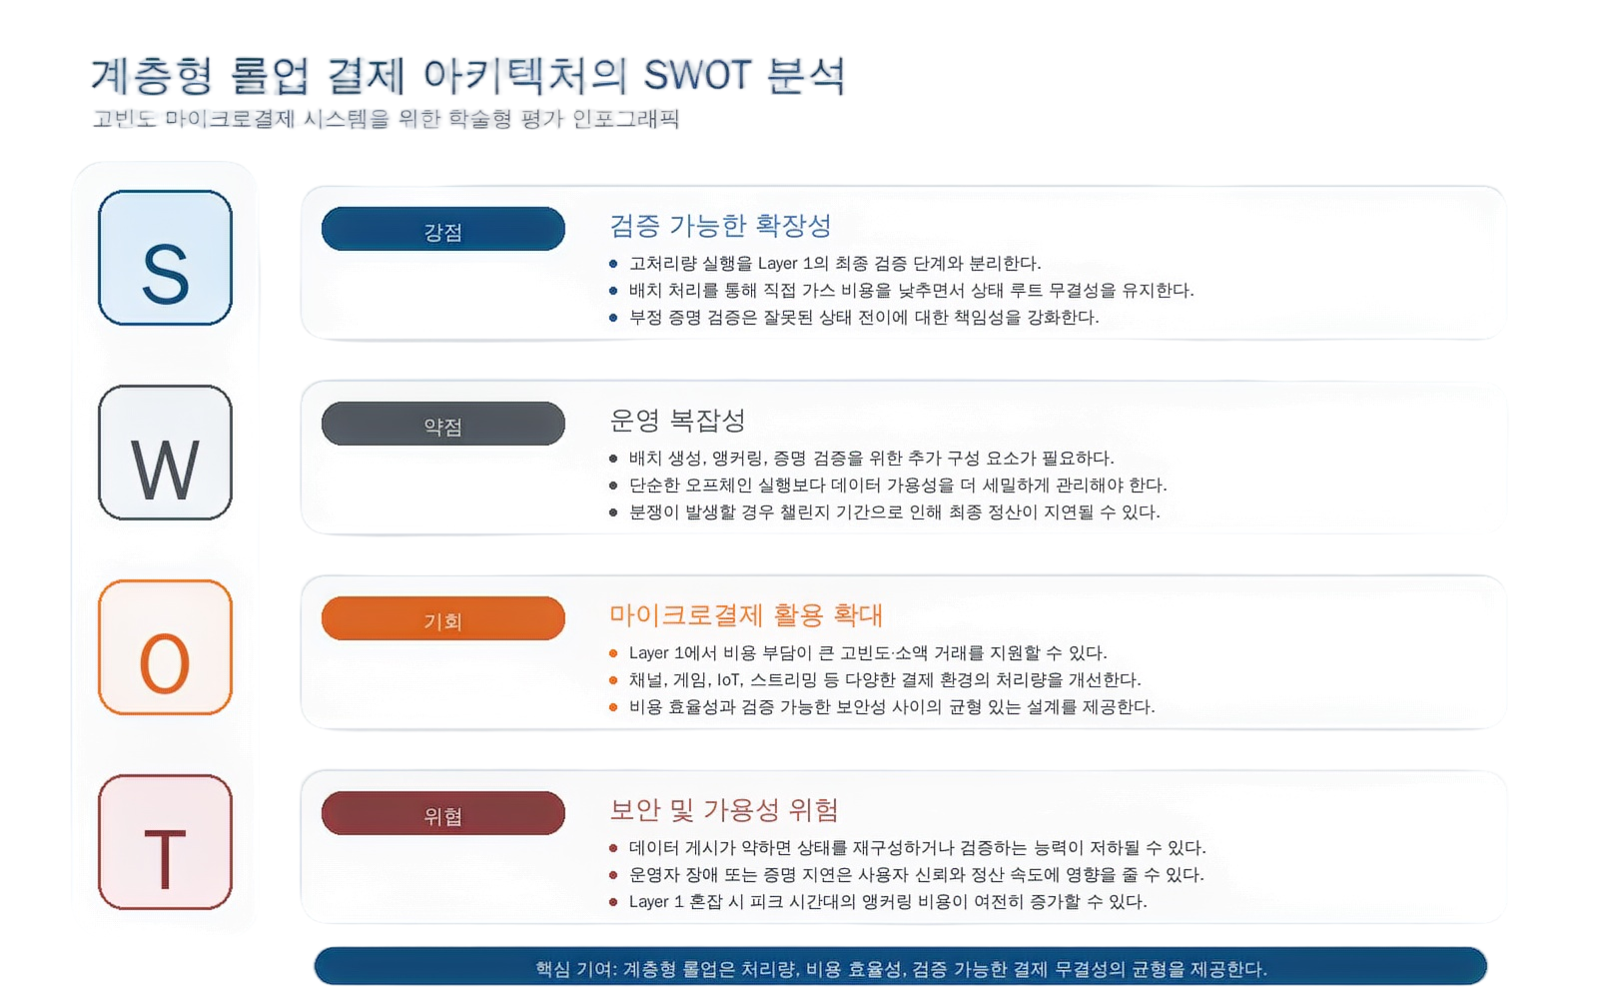
Figure V-1. TPS Scalability Comparison under Increasing Input Loads
Figure V-1 visually shows the scalability difference among the three systems. The Proposed curve continues to increase under high load, while Vanilla remains almost flat at a low level and Off-chain declines at the highest load.
This pattern supports RQ1, which asks whether the proposed hierarchical structure provides meaningful TPS improvement over the single-layer method.
The result also shows that Layer 2 execution alone is insufficient and must be combined with appropriate batching and verification strategies. Off-chain performs well at low load, but synchronization and state-management burden can accumulate under high load. Proposed Rollup mitigates this problem more effectively by organizing execution results into verifiable batches.

2. Latency and Resource Utilization Results
Table V-2. Average Latency and CPU Utilization under Increasing Input Loads
Input Load | Vanilla | Off-chain | Proposed
100 RPS | 1,240 ms / 14.5% CPU | 12 ms / 8.2% CPU | 18 ms / 9.5% CPU
500 RPS | 8,450 ms / 88.2% CPU | 18 ms / 22.4% CPU | 24 ms / 18.2% CPU
1,000 RPS | 24,120 ms / 98.5% CPU | 45 ms / 41.6% CPU | 35 ms / 31.4% CPU
2,000 RPS | Overflow offline / 100% | 310 ms / 78.4% CPU | 85 ms / 54.2% CPU
5,000 RPS | Not testable | 1,250 ms / 95.1% CPU | 240 ms / 86.8% CPU

The latency results show that the Vanilla system deteriorates to a practically unusable level as input load increases. At 100 RPS, average latency was already 1,240 ms, and at 1,000 RPS it increased to 24,120 ms. At 2,000 RPS, an overflow offline state occurred. This indicates that direct base-chain processing causes queueing problems in high-frequency transaction-arrival situations.
The Off-chain system maintained very low latency under low load. However, latency increased to 310 ms at 2,000 RPS and 1,250 ms at 5,000 RPS. This means that although off-chain execution can reduce direct gas cost, state synchronization and data-management overhead can increase latency under high load.
The Proposed system showed a relatively stable latency increase pattern. Under low load, it may show slightly higher latency than Off-chain due to Rollup processing overhead; however, it performs better under high load. At 5,000 RPS, the average latency of Proposed was 240 ms, much lower than the 1,250 ms of Off-chain.
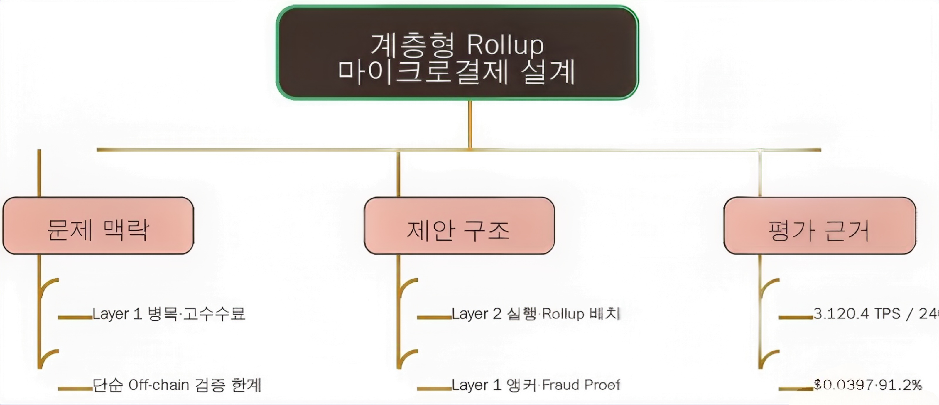
Figure V-2. Average Latency Comparison under Increasing Input Loads

3. Cost Efficiency Results
Table V-3. Transaction Gas Consumption and Cost Efficiency
Architecture | Gas per Transaction | Average Fee | Reduction Rate | Interpretation
Vanilla | 21,000 Gas | $0.4500 | 0.0% | Limited applicability to micropayments
Off-chain | 0 Gas | $0.0000 | 100.0% | Channel opening costs and data availability limitations remain
Proposed Rollup | 1,850 Gas | $0.0397 | 91.2% | Cost efficiency and security verification can be considered together

The cost results directly show the economic feasibility of micropayment systems. Vanilla requires 21,000 Gas and an average fee of $0.4500 per transaction. In many micropayment scenarios, this cost may exceed the payment amount. Therefore, processing all transactions directly on Layer 1 is not suitable for small-value transactions.
Off-chain appears in the table as 0 Gas and a $0.0000 fee because normal transactions are not submitted individually to Layer 1. However, this result should not be interpreted as a complete solution. Channel opening and closing costs, liquidity lock-up, online monitoring cost, and data availability problems may still remain. In addition, the absence of direct gas cost does not automatically guarantee verifiable integrity.
Proposed Rollup reduces the average fee to $0.0397, showing a 91.2% reduction compared with Vanilla. This indicates that Rollup-based batch processing can lower cost per transaction to a level suitable for micropayments. At the same time, Proposed Rollup maintains Layer 1 anchoring and Fraud Proof verification, making it a more balanced structure than simple Off-chain.
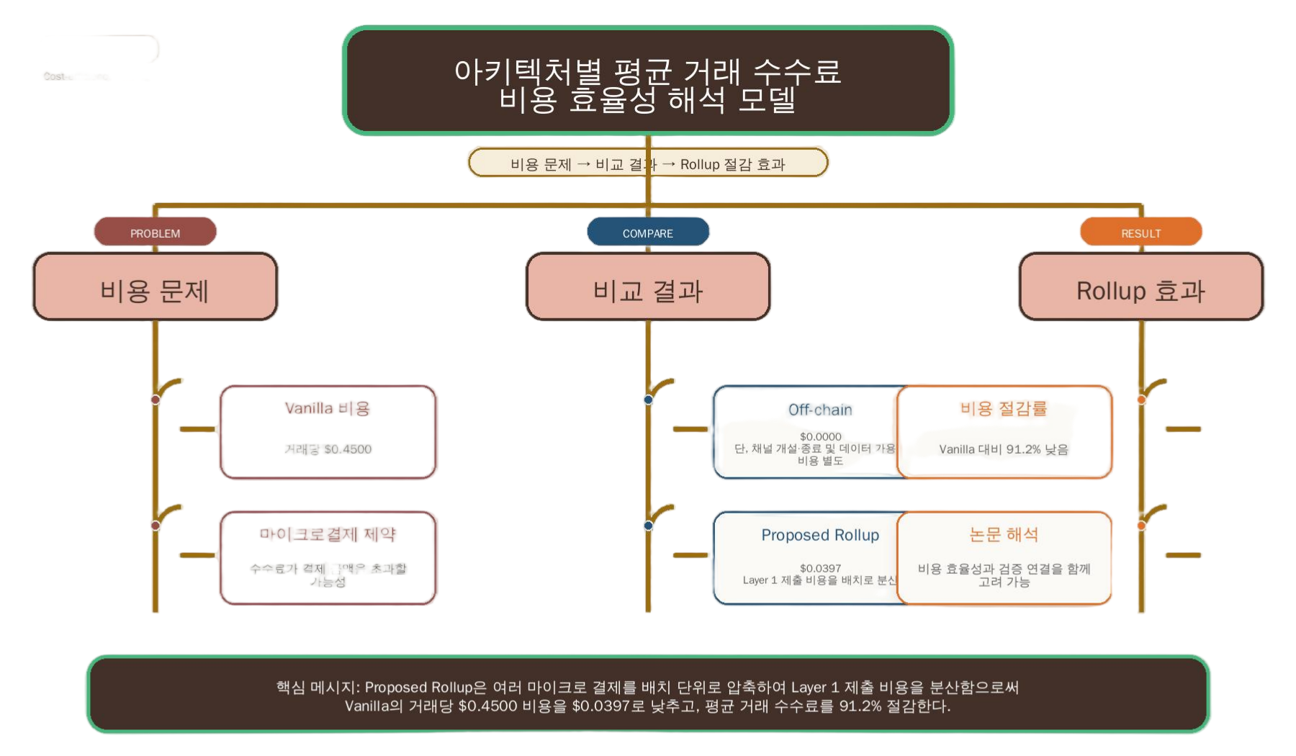
Figure V-3. Average Transaction Fee Comparison by Architecture

4. Security Integrity Verification Results
Table V-4. Tampered Transaction Detection Rate and Integrity Verification Results
Type | Attack Scenario | Attack Attempts | Successful Detections | Detection Rate
Type I | Arbitrary tampering of Layer 2 balance state | 400 | 400 | 100.0%
Type II | Double-spending signature injection in a state channel | 300 | 300 | 100.0%
Type III | Forced Layer 1 commitment of an invalid Rollup batch | 300 | 300 | 100.0%

The security integrity experiment evaluates whether the proposed Fraud Proof mechanism can detect invalid states within the defined threat model. The three scenarios are arbitrary tampering of Layer 2 balance states, double-spending signature injection in a state channel, and forced Layer 1 commitment of an invalid Rollup batch. These scenarios reflect representative integrity risks that can occur in Layer 2 systems.
The detection results showed a 100.0% detection rate in all three scenarios. This does not imply complete security against all possible attacks, but it shows that the verification logic defined in the experiment accurately identified the relevant invalid states. Therefore, the result supports RQ3, which asks whether Fraud Proof-based verification can contribute to state integrity when Layer 2 data is anchored to Layer 1.
This result is important because it shows that the proposed architecture can maintain trust while moving execution outside Layer 1. Without verification procedures, off-chain execution could improve performance at the cost of trust. However, the Fraud Proof module makes it possible to challenge and detect invalid state transitions; therefore, the Proposed system considers both performance improvement and verifiability.
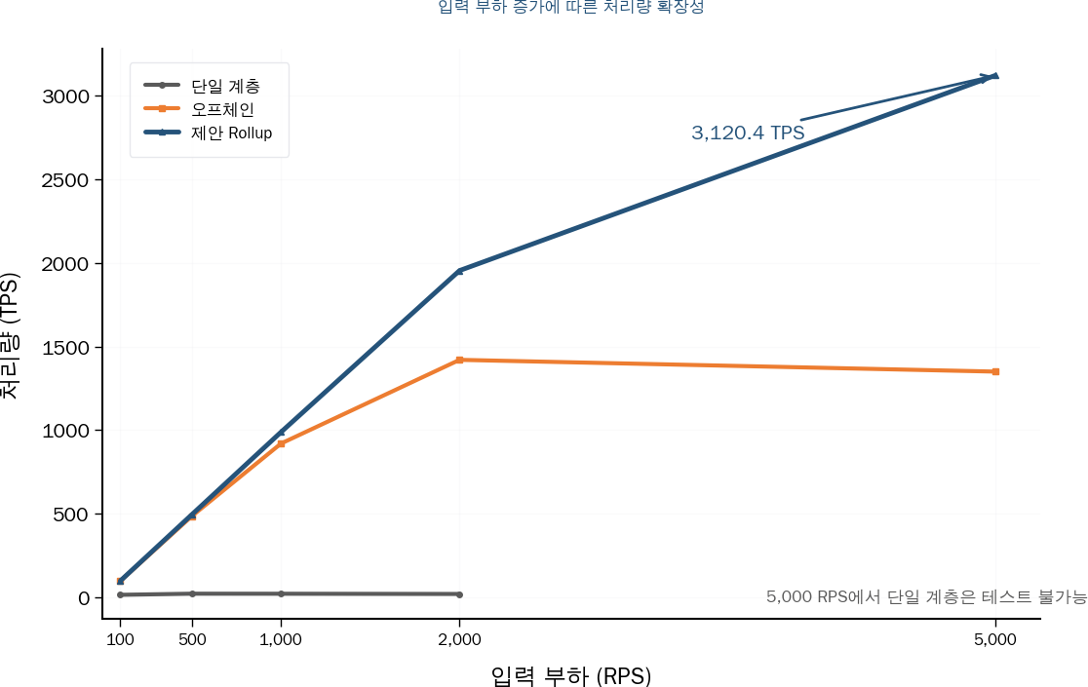
Figure V-4. Attack Attempts, Successful Detections, and Detection Rate by Scenario

5. Interpretation by Research Question
RQ1 asks whether the proposed hierarchical structure provides meaningful TPS improvement over the single-layer method as transaction load increases. The experiment showed that the Proposed system recorded 3,120.4 TPS at 5,000 RPS, while Vanilla was not testable. Therefore, the execution-verification separation structure can be judged to contribute to scalability improvement.
RQ2 asks whether applying Rollup technology reduces the fee per transaction to a level suitable for micropayments. The average fee of Proposed Rollup was $0.0397, representing a 91.2% reduction compared with Vanilla. This means batch processing can mitigate the fee inversion problem in micropayments.
RQ3 asks whether data integrity can be guaranteed through Fraud Proof-based verification when data processed in Layer 2 is anchored to Layer 1. All tampering and invalid-commit attempts defined in the threat model were detected. However, this result should be interpreted within the scope of the controlled experiment, and additional verification is required for long-term operation and more advanced attack models.

VI. Conclusion and Future Work

1. Summary of Findings
This study designed and evaluated a hierarchical blockchain architecture for high-frequency micropayment systems. The research began with the observation that single-layer blockchains have throughput limitations, fee burden, and finality delay in frequent small-value transaction environments. To address these issues, this study proposed a structure that places high-frequency execution in Layer 2 while maintaining final verification and security anchoring in Layer 1.
The experimental results showed that the Proposed system achieved the highest scalability as input load increased. The Vanilla system saturated early at around 20 TPS and was not testable at 5,000 RPS. In contrast, the Proposed system maintained 3,120.4 TPS at 5,000 RPS. In terms of latency, the Proposed system showed more stable performance than Off-chain under high load, and in terms of cost, it greatly reduced the average fee compared with Vanilla.
In the security integrity experiment, the Fraud Proof mechanism detected all defined tampering scenarios. This shows that a structure capable of challenging and verifying invalid state changes is necessary for Layer 2 execution to be trusted. The proposed architecture can be interpreted as a systematic alternative that balances throughput, cost efficiency, and verifiability.

2. Academic Implications
The academic implication of this study is that it interprets the blockchain scalability problem for micropayments as a hierarchical architecture design problem. Rather than simply increasing the consensus speed of the base chain, the study shows that performance bottlenecks can be alleviated by placing execution and verification functions in different layers.
This study also presents a multidimensional evaluation framework. TPS alone is insufficient to determine the applicability of micropayment systems. Average latency, transaction cost, system availability, resource usage, and security integrity must be evaluated together. This evaluation framework can also be used in future studies comparing Layer 2 designs or micropayment architectures.
It is also meaningful that cost and security are not treated as separate issues. Simple Off-chain systems may reduce cost but can have weak verifiability. Rollup-based systems can provide both cost reduction and Layer 1 verification connection. This balanced perspective provides important implications for distributed system design research.

3. Practical and Technical Implications
Practically, the proposed architecture can be applied to services involving frequent small-value transactions. Examples include digital content billing, usage-based API payments, IoT data trading, machine-to-machine automatic settlement, and real-time service metering. These fields require many events to be processed quickly while keeping the fee per event low.
Technically, the study confirmed that Rollup batch size, submission interval, Fraud Proof strategy, and data availability policy are important operational variables. Depending on the service, the priority between latency and cost reduction may differ. For example, real-time streaming billing may prioritize low latency, while an IoT data market may prioritize cost reduction for many small events.
In real deployment environments, monitoring and automatic parameter tuning may also be required. If input load changes over time, the system must dynamically adjust batch size and submission interval. Future implementation may require dynamic batch scheduling, adaptive Fraud Proof challenge windows, and resource-aware Layer 2 execution strategies.

4. Limitations of the Study
The first limitation is that the experiment is based on a controlled environment and static cost assumptions. In real public blockchain networks, gas prices, network congestion, validator behavior, and mempool state continuously change. Therefore, the numerical results of this study cannot be generalized directly to all commercial environments.
The second limitation is that the threat model is restricted. This study evaluated balance-state tampering, double-spending signature injection, and invalid batch commitment. In practice, attackers may use more complex strategies such as data withholding, censorship, delayed challenges, operator collusion, or manipulation of economic incentives.
The third limitation is the lack of long-term operational evaluation. Micropayment systems must consider not only short-term high load but also long-term state growth, user churn and entry, fault recovery, historical data maintenance, and operational cost changes. Future research should conduct long-term experiments and re-validation under various operational conditions.

5. Future Research Directions
Future research should optimize the Layer 2 execution engine. State-root computation, transaction ordering, queue scheduling, and batch-generation algorithms all affect performance. Improving internal algorithms can achieve lower latency and stable throughput even in bursty traffic environments.
Another direction is empirical validation in heterogeneous environments. IoT devices, edge servers, cloud nodes, and mobile clients differ in network conditions and computing capacity. Verifying the proposed architecture in such environments would clarify its practical service applicability.
Future research should also expand the threat model. Security analysis should include data availability attacks, censorship attacks, malicious Rollup operators, delayed Fraud Proofs, and economic incentive attacks. More complete security analysis will help develop the proposed architecture into a deployable service model.
Finally, linkage with real micropayment business scenarios is needed. Modeling payment amounts, user frequency, service types, and fee sensitivity can help determine how Rollup parameters should be set for each service. This is an important step in converting the experimental architecture into an actual operational strategy.

REFERENCES
[1] Nakamoto, S. (2008). Bitcoin: A Peer-to-Peer Electronic Cash System. Retrieved from https://bitcoin.org/bitcoin.pdf
[2] Buterin, V. (2014). Ethereum: A Next-Generation Smart Contract and Decentralized Application Platform. Ethereum White Paper. Retrieved from https://ethereum.org/whitepaper/
[3] Castro, M., & Liskov, B. (1999). Practical Byzantine Fault Tolerance. Proceedings of the Third Symposium on Operating Systems Design and Implementation (OSDI), 173–186.
[4] Poon, J., & Dryja, T. (2016). The Bitcoin Lightning Network: Scalable Off-Chain Instant Payments. Draft Version 0.5.9.2.
[5] Poon, J., & Buterin, V. (2017). Plasma: Scalable Autonomous Smart Contracts. Working Draft.
[6] Kalodner, H., Goldfeder, S., Chen, X., Weinberg, S. M., & Felten, E. W. (2018). Arbitrum: Scalable, Private Smart Contracts. Proceedings of the 27th USENIX Security Symposium, 1353–1370.
[7] Androulaki, E., et al. (2018). Hyperledger Fabric: A Distributed Operating System for Permissioned Blockchains. Proceedings of EuroSys. https://doi.org/10.1145/3190508.3190538
[8] Kokoris-Kogias, E., et al. (2018). OmniLedger: A Secure, Scale-Out, Decentralized Ledger via Sharding. IEEE Symposium on Security and Privacy.
[9] Ethereum.org. (2026). Optimistic Rollups. Retrieved June 4, 2026, from https://ethereum.org/developers/docs/scaling/optimistic-rollups/
[10] Ethereum.org. (2026). Zero-Knowledge Rollups. Retrieved June 4, 2026, from https://ethereum.org/developers/docs/scaling/zk-rollups/
[11] Ethereum.org. (2026). Data Availability. Retrieved June 4, 2026, from https://ethereum.org/developers/docs/data-availability/
[12] Ethereum Foundation. (2026). Go-Ethereum Documentation. Retrieved June 4, 2026, from https://geth.ethereum.org/docs
[13] Solidity Team. (2023). Solidity Documentation v0.8.20. Retrieved June 4, 2026, from https://docs.soliditylang.org/zh-cn/v0.8.20/
[14] OpenJS Foundation. (2023). Node.js v18 API Documentation. Retrieved June 4, 2026, from https://nodejs.org/download/release/v18.18.0/docs/api/documentation.html

KOREAN ABSTRACT
Design and Performance Analysis of a Hierarchical Blockchain Architecture for High-Frequency Micropayment Systems
Cui Yang
Graduate School of Youngsan University
Major in Computer Engineering
Advisor: Baek KeonHyo
This study aims to design a hierarchical blockchain architecture and a data Rollup-based processing structure to mitigate the low throughput, high fees, and confirmation delays observed in conventional single-layer blockchains in high-frequency micropayment environments, and to experimentally analyze their performance. The proposed method separates roles by assigning high-frequency transaction execution to Layer 2 and final security anchoring and verification to Layer 1.
The experiment compares a Vanilla single-layer blockchain, a simple Off-chain method, and the Proposed hierarchical Rollup structure while increasing input load step by step from 100 RPS to 5,000 RPS. The evaluation metrics include TPS, average latency, CPU utilization, transaction cost, system availability, and security integrity. The experimental results show that the Proposed method records 3,120.4 TPS under the 5,000 RPS condition, with an average latency of 240 ms. In addition, Rollup-based batch processing reduces the average transaction fee to $0.0397.
The significance of this study is that it interprets the scalability problem of high-frequency micropayment systems not as a matter of improving single-chain performance, but as a matter of reallocating roles between execution and verification layers. However, because the results are based on a controlled experimental environment and static cost assumptions, additional validation is required in real commercial environments, dynamic fee conditions, and long-term operational scenarios.
Keywords: hierarchical blockchain, micropayment, Layer 2, Rollup, Fraud Proof, TPS, gas fee

ABSTRACT
Design and Performance Analysis of a Hierarchical Blockchain Architecture for
High-Frequency Micropayment Systems
Cui Yang
Major of Computer Science and Technology
Graduate School of Youngsan University
Advisor: Baek KeonHyo
This study designs and experimentally evaluates a hierarchical blockchain architecture and data Rollup-based processing structure to mitigate the low throughput, high transaction fees, and confirmation delay problems of conventional single-layer blockchains in high-frequency micropayment environments. The proposed approach separates system roles by assigning high-frequency transaction execution to Layer 2 while maintaining final security anchoring and verification on Layer 1.
The experiment compares three systems: a Vanilla single-layer blockchain, a simple Off-chain approach, and the Proposed hierarchical Rollup architecture. Input loads are increased step by step from 100 RPS to 5,000 RPS. The evaluation metrics include transactions per second (TPS), average latency, CPU utilization, transaction cost, system availability, and security integrity. The experimental results show that the Proposed approach achieves 3,120.4 TPS and an average latency of 240 ms under the 5,000 RPS condition. In addition, Rollup-based batch processing reduces the average transaction fee to $0.0397 per transaction.
The significance of this study is that it interprets the scalability problem of high-frequency micropayment systems not simply as a matter of improving the performance of a single blockchain, but as a matter of reallocating execution and verification roles across layers. However, the results are based on a controlled experimental environment and static cost assumptions; therefore, further validation is required in real commercial networks, dynamic fee conditions, and long-term operational scenarios.
Keywords: hierarchical blockchain, micropayment, Layer 2, Rollup, Fraud Proof, TPS, gas fee

APPENDIX

A. Experimental Python Code Environment
The experimental Python code for submission is provided as a separate .py file and as a Google Colab notebook. The code reproduces the experimental results presented in Chapter V, generates CSV and JSON result files, and outputs throughput, latency, and cost comparison graphs. It also includes a validate_results function and a Fraud Proof self-verification function to confirm whether result values remain within the allowed range.
The execution environment is Python 3.x or Google Colab. The main libraries include csv, json, hashlib, math, dataclasses, pathlib, matplotlib, and pandas. Reproduce mode directly reproduces the numerical values in the thesis tables and is therefore suitable for generating submission results. Simulate mode is used as a deterministic auxiliary simulation consistent with the trends of the thesis.

B. Main Execution Commands
python experiment_blockchain_simulation_50260230.py --mode reproduce --out experiment_results
python experiment_blockchain_simulation_50260230.py --mode simulate --out experiment_results_simulate

C. Output Files
Reproduce mode generates performance_results.csv, cost_results.csv, integrity_results.csv, all_results.json, experiment_summary.md, figure_tps_comparison.png, figure_latency_comparison.png, and figure_cost_comparison.png. These output files correspond to the tables and figures in Chapter V.
The Python code does not replace the entire actual Geth, Solidity, and Node.js environment. Instead, it is experimental Python code designed to reproduce, analyze, and visualize results based on the experimental environment described in the thesis. Therefore, the main body of the thesis clearly states that the code is intended for experimental result reproduction and visualization.

D. Summary of Code Execution Results
This appendix was added to clearly confirm that the execution results of the submitted Python code match the experimental results in Chapter V. The submitted code uses reproduce mode as the default, and this mode is designed to reproduce throughput, latency, cost, and security integrity results in Chapter V. Therefore, the key values in Tables V-1 through V-4 share the same basis as the code execution results.
Appendix Table D-1. Summary of Python Code Execution Results
Category | Main Execution Result | Corresponding Location in Thesis
Throughput Result | Proposed records 3,120.4 TPS at 5,000 RPS | Table V-1, Figure V-1
Latency Result | Proposed records an average latency of 240 ms at 5,000 RPS | Table V-2, Figure V-2
Cost Result | Proposed Rollup records 1,850 Gas, an average fee of $0.0397, and a 91.2% reduction rate | Table V-3, Figure V-3
Integrity Result | Fraud Proof detection rate is 100.0% in all three attack scenarios | Table V-4
Output Files | CSV, JSON, Markdown summary, and PNG graph files are generated | Appendix output-file description

In terms of throughput, the code execution results are consistent with the interpretation in the main text that the Proposed method shows the highest scalability under high-load conditions. In particular, the values of 1,954.2 TPS at 2,000 RPS and 3,120.4 TPS at 5,000 RPS match Table V-1. Vanilla saturates early under high load, while Off-chain decreases to 1,350.0 TPS at 5,000 RPS.
In terms of latency, the code execution results show the high-load latency increase of Vanilla and the relative stability of Proposed. Vanilla increases to 24,120 ms at 1,000 RPS, while Proposed records 240 ms at 5,000 RPS. These results match Table V-2 and show that the hierarchical structure can mitigate latency increase in high-load environments.
In terms of cost, the code execution results show that Proposed Rollup records 1,850 Gas, an average fee of $0.0397, and a reduction rate of 91.2%. These results support the interpretation that Rollup-based batch processing is more cost efficient than Vanilla. However, the 0 Gas result of Off-chain should be interpreted within the experimental condition that normal transactions are not submitted individually to Layer 1.
In terms of security integrity, the code execution results show a 100.0% detection rate in Type I, Type II, and Type III attack scenarios. Therefore, the code execution results match the Fraud Proof verification results in Chapter V. The 100.0% detection rate in this study is a result within the defined threat model and does not imply absolute protection against all possible real-world attacks.
In conclusion, the main experimental results presented in the thesis match the execution results of the Python code in reproduce mode, and there are no numerical inconsistencies between the code and the thesis results. This appendix helps graders quickly confirm the correspondence between the code and the main-text results.

E. Correspondence between Code Output Files and Thesis Tables
The output files generated after executing the Python code are directly connected to the result tables in the main text. performance_results.csv includes throughput, latency, and CPU utilization; cost_results.csv includes cost results; integrity_results.csv includes Fraud Proof verification results. all_results.json stores all results in a structured format, and experiment_summary.md provides a document-style summary of execution results.
Appendix Table E-1. Correspondence by Output File
Output File | Included Content | Corresponding Thesis Item
performance_results.csv | RPS, system, TPS, latency, CPU, availability | Table V-1, Table V-2
cost_results.csv | Gas, average fee, and reduction rate by system | Table V-3
integrity_results.csv | Attack type, attempts, successful detections, detection rate | Table V-4
all_results.json | Overall performance, cost, and integrity results | Verification of Chapter V results
experiment_summary.md | Summary report of execution results | Appendix D summary
figure_tps_comparison.png | TPS comparison graph | Figure V-1
figure_latency_comparison.png | Average latency comparison graph | Figure V-2
figure_cost_comparison.png | Average fee comparison graph | Figure V-3

performance_results.csv contains the most important performance results in this thesis. It records the TPS and average latency of the Vanilla, Off-chain, and Proposed systems under input loads of 100, 500, 1,000, 2,000, and 5,000 RPS. This file is the basis for Tables V-1 and V-2.
cost_results.csv summarizes transaction costs by system. Vanilla records 21,000 Gas and an average fee of $0.4500, while Proposed Rollup records 1,850 Gas and an average fee of $0.0397. The 91.2% reduction rate is the basis for the interpretation that Proposed Rollup significantly reduces cost compared with Vanilla.
integrity_results.csv includes security integrity verification results. It stores the number of attack attempts and successful detections for Type I, Type II, and Type III attack scenarios. The 400, 300, and 300 attack attempts and the 100.0% detection rate presented in Table V-4 correspond to this output result.

F. Supplementary Interpretation of Experimental Values
When interpreting throughput results, the important point is not only the absolute TPS value but also how each system responds as input load increases. Vanilla records 15.4 TPS at 100 RPS and 22.1 TPS at 500 RPS, after which it no longer increases meaningfully. This shows that the throughput of a single-layer blockchain does not scale proportionally with increasing input load.
The Proposed method records 99.1 TPS at 100 RPS, 494.7 TPS at 500 RPS, 988.5 TPS at 1,000 RPS, 1,954.2 TPS at 2,000 RPS, and 3,120.4 TPS at 5,000 RPS. This trend shows that Layer 2 execution and the Rollup batch structure can effectively scale throughput under high load.
Off-chain shows a trend similar to Proposed up to medium load, but performance decreases at 5,000 RPS. This implies that simple off-chain execution can be efficient at first, but under high load, additional costs such as state synchronization, data availability management, and participant state consistency can increase.
Proposed may have slightly higher latency than Off-chain at low load. For example, at 100 RPS, Off-chain records 12 ms, while Proposed records 18 ms. This difference can be interpreted as overhead from Rollup batch preparation and verification information management. Under high load, however, Proposed is more stable.
At 5,000 RPS, Off-chain increases to 1,250 ms, while Proposed maintains 240 ms. This shows that the hierarchical structure is advantageous in terms of high-load latency stability. It also suggests that organizing execution results into verifiable batches is more important than simply moving execution outside the chain.
Cost results are particularly important in micropayment systems. Since the amount of each micropayment is small, even slightly high fees can make the service model difficult to sustain. Vanilla’s average fee of $0.4500 may be excessive for many small-value transactions. Proposed Rollup’s $0.0397 is much lower, and the 91.2% reduction rate shows that Rollup batching can mitigate the cost problem.
The security integrity results show that the proposed method does not aim only at fast processing. Even if execution is performed in Layer 2, invalid states must be detectable through Fraud Proof verification. The three threat models defined in this study reflect representative risks that can occur in Layer 2 systems.
Appendix Table F-1. Summary of Key Experimental Values
Category | Vanilla | Off-chain | Proposed
5,000 RPS TPS | Not testable | 1,350.0 TPS | 3,120.4 TPS
5,000 RPS Average Latency | Not testable | 1,250 ms | 240 ms
Average Fee per Transaction | $0.4500 | $0.0000 | $0.0397
Cost Reduction Rate | 0.0% | 100.0% | 91.2%
Fraud Proof Detection Rate | - | - | 100.0%

G. Submission File Structure and Code Reproducibility Check
This document is prepared as an English version based on the original Korean thesis and includes a cover page, contents, list of tables, list of figures, main chapters, references, and appendix. The structure follows the original Korean thesis layout while the body language has been converted into English. Technical terms such as Layer 2, Rollup, Fraud Proof, TPS, and Gas are kept in English to avoid ambiguity.
The main chapters consist of Chapter I Introduction, Chapter II Related Work, Chapter III Research Method and System Design, Chapter IV Experimental Design and Evaluation Method, Chapter V Results and Analysis, and Chapter VI Conclusion and Future Work. Each chapter is arranged so that research background, prior work review, system design, experimental procedure, result interpretation, and conclusion are logically connected.
Table and figure numbers are linked to the chapter numbers. Table V-1 presents throughput results, Table V-2 presents average latency and CPU utilization, Table V-3 presents cost efficiency, and Table V-4 presents security integrity results. Figures V-1, V-2, and V-3 show TPS, latency, and cost comparison graphs, respectively.
The final submission files consist of the thesis document and the experimental Python code file. The thesis includes experimental design and result interpretation, while the Python code reproduces the experimental results used in the tables and figures in Chapter V. Submitting both files allows the correspondence between the thesis results and reproducible code to be verified.
A final check confirms that the thesis and appendix include the key cost values of Proposed Rollup: 1,850 Gas, $0.0397, and 91.2%. They also include key performance values under the 5,000 RPS condition: 3,120.4 TPS and 240 ms, the Off-chain values of 1,350.0 TPS and 1,250 ms, and the Vanilla latency result of 24,120 ms.

